**ASSIGNMENT 2:**

**Module 3: Control Structures in Python**

**Task 1: Check if a Number is Even or Odd**

**Problem Statement:** Write a Python program that:

1. Takes an integer input from the user.



1. Checks whether the number is even or odd using an if-else statement.

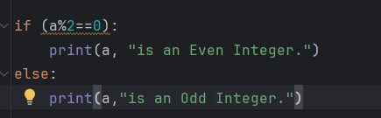

1. Displays the result accordingly.

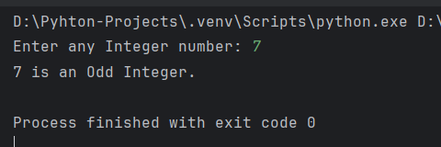

==========================================================================

**Task 2: Sum of Integers from 1 to 50 Using a Loop**

**Problem Statement:** Write a Python program that:

1. Uses a **for loop** to iterate over numbers from **1 to 50**.

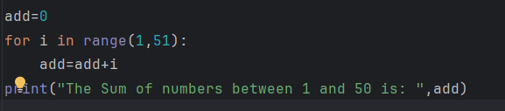

1. Calculates the **sum** of all integers in this range.

Using logic:

add=0

For each iteration of count from 1 to 50:

Then, add=add+count

3.   Displays the final sum.

